Histomorphogenesis of human lacrimal gland

Dr Romesh Chander, Dr Sheetal Chandel*, Dr Nusrat Jabeen

*Corresponding Author:
Dr Sheetal Chandel
H.no. 112 Lane no. 1 Pritam Nagar Paloura Jammu Near Talab Pin 181121

Type of Publication: Original Research Paper
Conflicts of Interest: Nil

ABSTRACT
The aim of this study was to determine the main stages of the lacrimal’s gland developmental process in humans. To study the microscopic and connective tissue changes during stages of lacrimal gland development and to study the time of appearance of glands/acini and their subsequent development in the gland. Study was conducted on 25 foetuses of different gestational periods obtained from the Department of Anatomy, Government Medical College, Jammu. Assessment of age of foetuses was done according to the rule as described by Hamilton et al (1976). Results of this study were described in foetuses of increasing crown-Rump length. Foetuses divided into six groups and lacrimal gland being described has main components of gland as acini, ducts, connective tissue septa and structures like blood vessels, muscle fibres etc.

Keywords: lacrimal duct, lacrimal gland, connective tissue, CRL( Crown rump length)

INTRODUCTION
The lacrimal apparatus is divided into two components, the secretory system and the excretory system. The secretory system comprises of those structures which contribute to the formation of tear film, synthesized primarily by the lacrimal gland. The excretory system formed by the lacrimal puncta, lacrimal canaliculi, lacrimal sac and lacrimonasal duct, collects the tear film and drains it into the nasal cavity. Lacrimal gland can be divided into two groups lacrimal gland proper and the accessory lacrimal gland, the latter group includes glands of krausse, tarsal gland and those in caruncle and the plica. Tha lacrimal gland varies in shape and is separated anteriorly into two lobes (superior or orbital and inferior or palpebral) by lateral extension of the aponeurosis of the levator palpebrae superioris muscle (Jakobiec and Iwamoto, 1982). Excretory ducts roughly about twelve in number, two to five originate from the superior lobe and six to eight from the inferior lobe open into superotemporal portion of the forniceal conjunctiva and one or more duct may open into the conjunctival sac near the lateral canthus or even below it (Duke-Elder and Wybar, 1961). While going through the literature available on the development of lacrimal gland, the detailed time table of appearance of different components of lacrimal gland and histological changes in it during different phases of development are lacking, so due to scarcity of literature, controversy and difference of opinion regarding development of lacrimal gland, it was worthwhile to initiate a study on the histomorphogenesis of human lacrimal gland to find out proper sequence of its development.
Material and Methods: Present study was conducted on 25 foetuses of different gestational age. The foetuses were examined macroscopically and any specimen with any congenital malformation was excluded from the study. The foetuses to be measured were kept on a plane board with knee and hip joints, flexed at 90 degrees each. With the help of Vernier calliper the crown rump length was measured from vertex to breech. Assessment of age of the foetuses was done according to the rule as described by Hamilton et al. (1976) which states that at 32days of intrauterine life, embryo is 5mm in crown-rump length. For each additional day upto 55th day, the embryo grows at the rate of 1mm per day and after 55th day embryonic growth is 1.5mm per day with respect to its crown-rump length.
Foetuses were dissected to take out the gland. Each dissected specimen was kept inside a special metallic tissue capsule container, a number and side right/left marking was done.
The specimen was fixed in 10% formalin solution and then preparation of tissue for section was done by paraffin wax embedding method. Various steps used were:-
- Dehydration
- Clearing
- Paraffin wax impregnation
- Casting or embedding
- Sectioning : Sections 6-8 microns in thickness were taken. In case of large specimen every 10th serially cut section was taken and in smaller specimen every 5th serially cut section was selected.
- Fixation of sections on slides
- Staining : The various types of staining methods used were:
Haematoxylin and eosin staining
Masson’s trichrome staining
The stained slides were observed under the microscope. Photographic documentation was done to notice important findings.
Results: The study undertaken is concerned with the histomorphogenesis of lacrimal gland. The following observations are based on the histological study conducted on 25 foetuses of different age groups ranging from 40mm to 300mm crown rump length. For better understanding of the development process, the foetuses have been divided into six groups.
The lacrimal gland being described has main components of gland as acini, ducts, connective tissue and structures like blood vessels, musclefibres etc, which are developing along with the gland.

Group | Crown rump length  (mm) | Number of foetuses
1 | 40-70 | 4
2 | 75-120 | 4
3 | 130-170 | 4
4 | 175-215 | 4
5 | 220-260 | 4
6 | 265-300 | 5
Total | 40-300 | 25

Group 1 (40mm-70mm) - Lacrimal gland was observed to be quite rudimentary, seen as solid epithelial cords ingrowing into the underlying mesenchyme at 40mmcrown rump length (fig 1). Initially the number of ectodermal ingrowths was less. To begin with, these epithelial cords were solid and formed of large polyhedral cells. Later we could see degeneration of central cells leading to the formation of lumen at 70mm CRL. These linear cords of cells initiated branching at 65mm CRL and branching become more obvious in foetuses of higher CRL. Connective tissue was in the form of sheet into which the epithelial buds grow during initial stages and connective tissue was observed in abundance in this group as compared to ductal components.

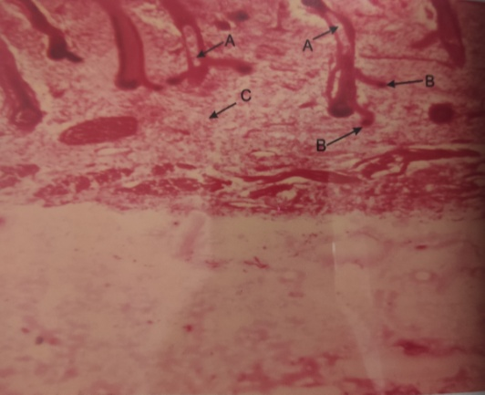
FIGURE 1

- Ingrowing ectodermal epithelial solid cords.
- Mesenchyme
Seen in 40mm cr length foetus h&e
Group 2 (75mm-120mm) – The lacrimal gland was still rudimentary. Development and increased canalization of ducts was the feature of this group. At the terminal ends of branching ducts, globular structures as acini were noticed, which were yet uncanalized in foetuses of 75mm CRL. At 90mm CRL the beginning of canalization in acini was observed (Fig 2). At 110 and 120mm CRL, the acini appeared in the form of bunch of grapes at the terminal ends of the ducts and the acini started dominating the picture. The levator palpebrae superioris muscle made its appearance at 75mm CRL. Connective tissue components were in abundance. The mesenchyme starts arranging itself as fibre bundles. The fibres form septae and septae divide the parenchyma containing different clusters of acini. Well developed septae are seen at 120mm CRL and these septae divide the gland into various lobes and lobules. Blood vessels were initially noted in 90mm CRL.

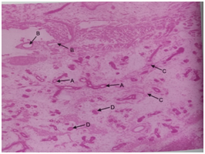
FIGURE 2

- Initiation of canalization in acini.
- Blood vessels.
- Bundles of mesenchyme tissue.
- Uncanalized acini seen in foetus of 90mm cr length h&e.
Group 3 (130mm-170mm CRL)- At this stage acini were seen in clusters. Acinar diameter observed to increase as CRL increased. Glandular component started dominating the picture. Blood vessels were seen in connective tissue septae along with interlobular ducts. Connective tissue arranges itself into various septae dividing the gland into various lobes and lobules. Lumen is clearly observed in acini. So lobulation was a prominent feature of this group.
Group 4 (175-215mm)- Sections of gland in this group shows increased number of lobes and lobules (Fig 3). Glandular component was dominating the picture compared to duct system and connective tissue component at 175mm CRL. Vascularity of gland has increased. There is increase in number as well as canalization of ducts. The lining epithelium of ducts is multilayered.

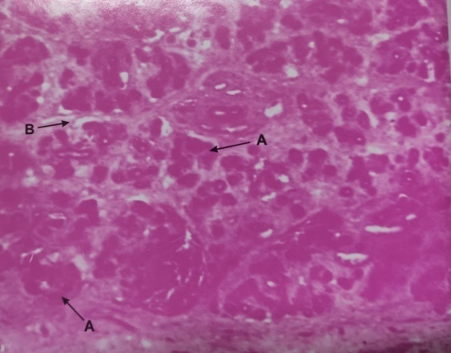
FIGURE 3
- Acini seen as end pieces in groups.
- Connective tissue septae dividing the gland into lobes seen in foetus of 170mm cr length.

Group 5 (220-260mm)- In this group there is increase in number of lobes and lobules, increased canalization of both acini and ducts is seen but at this stage the acini have dominated the picture. Actual glandular acini formation starts and also increased lobulation is seen. In this group the gland look like adult gland.
Group 6 (265-300mm CRL)- In this group the diameter of acini decreased with less connective tissue in between. Epithelium of acini is decreased to single layer. Various ducts as intralobular, interlobular and excretory ducts are seen with epithelial lining of cuboidal, columnar and pseudostratified. Vascularity of gland increases many folds. It also shows marked reduction in connective tissue and connective tissue spaces. The gland prepares itself for secretory activity with single layer cells in acini with various types of ducts in interstitial connective tissue.
Discussion: The available literature exhibits that many workers since early period have been engaged in the morphological histological studies of exocrine glands in general. Some studies about development of the exocrine gland have been attributed to lacrimal gland only but still many aspects of the developmental sequence has been incompletely documented. The present study ‘The Histomorphogenesis of human lacrimal gland’ is an experimental approach to the development of various components of human lacrimal gland. The development of human lacrimal gland is an epithelial-mesenchymal interaction (Kammandel et al. 1999).
In the present study, at 40mm CRL gestation, formation of buds and solid cords of epithelial origin at the level of superior conjunctival fornix was seen. Initially the number of these epithelial cords was less but with increase in CRL, the number increases. These cords were seen dipping into the surrounding mesenchymal tissue. Similar observations were made on human embryo by Special- Cirincione(1908). According to the observations made by Keibel and Elze (1911), earliest analogue of lacrimal gland in embryos was seen at 22-26mm CRL stage as knob like ingrowth from superior conjunctival fornix, which is similar to the present study. Formation of similar epithelial buds were seen by Duke-Elder and Cook (1963) in foetuses of 22-25mm CRL. Murube (1982) and Ozanics and Jackobiec(1982) put forth similar observations at 22-25mm CRL.
In the present study, at 70mm CRL of gestation branching of epithelial buds was noticed along with lumen formation. Similar findings were seen by Special-Cirincione (1908). Neely (1937) observed the branching in foetuses of 38mm CRL.
In the present study, cords of cells were seen at 40mm CRL and by 53mm CRL, degeneration of innermost cells of cords and beginning of canalization were observed. Similar findings were noted in study done by Neely (1937), Duke-Elder and Cook (1963) and Snell (1975). In the present study, during 75mm CRL gestational age levator palpebrae superioris was seen dividing the gland into palpebrae and orbital parts. Similar observations were made by Special- Cirincione (1908), Duke Elder and Cook (1963) and Murube-del-castillo (1982).
In the present study at 40mm CRL the connective tissue was seen as sheet mesenchyme into which the epithelial buds were seen growing and branching leading to the formation of ducts and parenchymal system of lacrimal gland. Our findings are in accordance with the findings of Special-Cirincione (1908), Duke- Elder ND Cook (1963) and Snell (1975).
The study concludes that as we reached 300mm CRL, all the components of lacrimal gland are seen. There was still scope of development of lacrimal gland histologically into more mature state which may include components like fat cells, which form feature of mature lacrimal gland. With maturity of gland, there is decrease in connective tissue component and increase in glandular with secretory component.
Bibliography:
- Allen M, Wright P and Reid L. The human lacrimal gland. A histochemical and organ culture study of the secretory cells. Arch ophthalmol 1972; 88: 493-497.
- Cook CS, Ozanics V and Jakobiec FA. Prenatal development of eye and its adnexia. In: Duane’s Foundation of clinical ophthalmalology, 1st edition. Lippincotts Williams and Wilkins 2006; vol 1: chapter 2.
- de La Cuadra-Blanco C, Peces-Pena MD and Merida Velasco JR. Journal of Anatomy 2003; 203(5): 531-536.
- Duke-Elder S and Cook C. The lacrimal gland. In: Duke-Elder S (editor), System of ophthalmology, Part 1. London; Kimpton, 1963; Vol.VIII: PP. 239-241.
- Duke-Elder S and Wybar KC. The anatomy of the visual system. In: Duke-Elder S (editor), System of Ophthalmology. St Louis: CV Mosby, 1961; vol 2: pp. 562-568.
- Murube-del-Castillo J. Dacriologia Basica, 2ND Edition. Madrid, 1982: pp. 57-59.
- Neely JM. Mixed tumors of lacrimal gland. Review of literature and case report. Am J Pathology 1937; 13(1): 99-108.
- Snell RS. Clinical Embryology for Medical students, 2nd edition. Boston: Little, Brown and Company, 1975; pp. 330.
- Special-Cirincione F. Uber die Entwicklung der Tranendruse beim Menschen. Graefes Arch Clin Exp Ophthalmol 1908; 69: 193.
- Srinivasan BD, Worgul BV, Iwamoto T et al. The conjunctival epithelium. II. Histochemical and ultrastructural studies on human and rat conjunctiva. Ophthalmol Res 1979; 9: 65-79.

